Moreover, I  
realized that the work of cleaning the HTML and text for each person’s  
blog post would not be so bad. In fact, it turned out to be as easy as  
reapr::reap_url() %>% reapr::mill() (with only a little bit of extra  
work )!

After trying a couple of different approaches (e.g. bigrams, topic  
modeling, etc.) and experimenting with some different visualizations, I  
ended up making the two plots below. (To the interested reader, I’ve  
included all of the code at the bottom of this post.) From the second  
plot—where positive sentiment heavily outweighs negative sentiment—one  
thing is clear: the R community is **super supportive and positive**,  
just as Nick alluded to in his tweet.

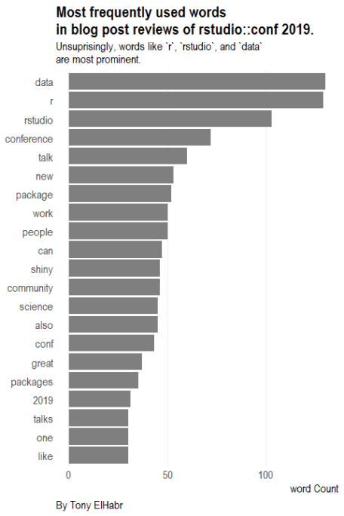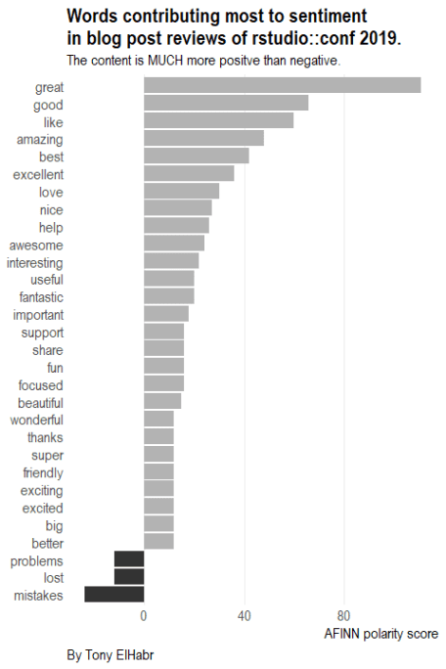

I’ve said it before and I’ll happily said it again: everything else that  
they’ve done for the community! The techniques that they’ve documented  
and shared are super helpful for doing a quick exploration just like  
this.

# Reference for adding appendix: https://yihui.name/en/2018/09/code-appendix/

DIR_POST <- "content/post/rstudio-conf-2019-summary"

PATH_SANS_EXT <- "index-to-render"

PATH_RMD <- file.path(DIR_POST, paste0(PATH_SANS_EXT, ".Rmd"))

PATH_OUTPUT <- file.path(DIR_POST, paste0(PATH_SANS_EXT, ".md"))

# PATH_R <- paste0(PATH_SANS_EXT, ".R")

# rmarkdown::render(knitr::spin(PATH_R, knit = FALSE))

# # Spell-checking.

# spelling::spell_check_files(PATH_RMD)

# # Convert from Rmd to output specified in YAML.

# rmarkdown::render(PATH_RMD, output_file = PATH_OUTPUT, output_dir = DIR_POST, knit_root_dir = DIR_POST, intermediates_dir = DIR_POST)

# rmarkdown::render(PATH_RMD)

# rmarkdown::render(PATH_RMD, output_file = PATH_OUTPUT)

knitr::opts_knit$set(root.dir = here::here(DIR_POST))

knitr::opts_chunk$set(

echo = FALSE,

cache = FALSE,

include = FALSE,

fig.show = "hide",

fig.align = "center",

fig.width = 4.5,

fig.asp = 1.5,

warning = FALSE,

message = FALSE

)

library("tidyverse")

library("teplot")

# library("hrbrthemes")

# theme_set(teplot::theme_te())

url <- "https://github.com/kbroman/RStudioConf2019Slides/blob/master/ReadMe.md"

page <- url %>% reapr::reap_url()

nodes_p <- page$parsed_html %>% rvest::html_nodes("p")

# nodes_p %>% rev() %>% magrittr::extract(1:20)

extract_nodes_after <- function(x, pattern) {

stopifnot(class(x) == "xml_nodeset")

text <- rvest::html_text(x)

mask <- str_detect(text, pattern)

mask <- dplyr::cumany(mask)

x[mask]

}

nodes_blogposts <-

nodes_p %>%

extract_nodes_after("^Jacqueline Nolis")

str_subset_inv <- function(string, pattern, invert = TRUE) {

setdiff(string, str_subset(string, pattern))

}

extract_nodes_without <- function(x, pattern) {

stopifnot(class(x) == "xml_nodeset")

text <- rvest::html_text(x)

res <- str_subset_inv(text, pattern)

res

}

# nodes_blogposts %>% rvest::html_text()

# nodes_blogposts %>% rvest::html_nodes("a") %>% rvest::html_text()

links <-

nodes_blogposts %>%

rvest::html_nodes("a") %>%

rvest::html_attr("href") %>%

str_subset_inv("twitter|reources")

mdtext <- nodes_blogposts %>% rvest::html_text()

authors <- mdtext %>% str_extract("(^[^,]+)")

# titles <- mdtext %>% str_replace("(^.*)\\,[\\s\\n]+(.*$)", "\\2")

blogposts <-

tibble(

idx_blog = seq.int(1L, length(authors)),

author = authors,

link = links

)

blogposts

# Exclude Nolis and Lopp due to difficulty with Medium articles.

# Exclude Cortina because it is an "analysis" type of article.

# Exclude Nantz because it is just a description of a podcast.

blogposts_filt <-

blogposts %>%

filter(!str_detect(author, "Nolis|Lopp|Cortina|Nantz"))

blogposts_content <-

blogposts_filt %>%

mutate(content = purrr::map(link, ~reapr::reap_url(.x) %>% reapr::mill()))

blogposts_content

# content1 <-

# blogposts %>%

# slice(2) %>%

# pull(link) %>%

# reapr::reap_url() %>%

# reapr::mill()

#

# tokens1 <-

# content1 %>%

# str_split("\\n") %>%

# enframe(name = "line", value = "text") %>%

# unnest() %>%

# # Still some empty lines to remove.

# filter(text != "") %>%

# # tidytext::unnest_tokens(output = "word", text)

# tidytext::unnest_tokens(output = "ngram", input = text, token = "ngrams", n = 3)

# tokens1

tidy_1post <-

function(text) {

text %>%

str_split("\\n") %>%

enframe(name = "line", value = "text") %>%

unnest() %>%

# Still some empty lines to remove.

filter(text != "") %>%

# For unigrams.

tidytext::unnest_tokens(output = "word", input = text)

# For bigrams.

# tidytext::unnest_tokens(output = "ngram", input = text, token = "ngrams", n = 2)

}

posts_tokenized <-

blogposts_content %>%

select(-link) %>%

mutate(tokens = purrr::map(content, tidy_1post))

posts_tokenized

tokens <-

posts_tokenized %>%

select(author, tokens) %>%

unnest(tokens)

tokens

stopwords_base <- tidytext::get_stopwords()

# stopwords_base <- tidytext::get_stopwords(source = "smart")

# Remove the numbers used for ordered lists as well as html-related things

# (mostly from Medium posts?).

stopwords_custom <-

as.character(0:9) %>%

# c(

# "https",

# "url",

# "href",

# "httpstatus",

# "alts",

# "anchortype",

# "rel",

# "github.com",

# "200",

# "markups",

# "name",

# "text",

# "title",

# "type",

# "start",

# "end",

# "originalwidth",

# "originalheight",

# "true",

# "false",

# "id"

# ) %>%

tibble(word = .)

stopwords <-

bind_rows(stopwords_base, stopwords_custom)

tokens %>%

count(word, sort = TRUE)

tokens %>%

anti_join(stopwords) %>%

count(author, word, sort = TRUE)

# # If `ngram` is a bigram, then...

# tokens_filt <-

# tokens %>%

# separate(ngram, into = c(paste0("word", 1:2)), remove = FALSE) %>%

# anti_join(stopwords, by = c("word1" = "word")) %>%

# anti_join(stopwords, by = c("word2" = "word"))

# tokens_filt

tokens_filt <-

tokens %>%

anti_join(stopwords)

tokens_filt

theme_custom <- function() {

teplot::theme_te(base_size = 12) +

theme(panel.grid.major.y = element_blank())

}

lab_title_suffix <- "in blog post reviews of rstudio::conf 2019."

lab_caption <- "By Tony ElHabr"

tokens_filt_n <-

tokens_filt %>%

count(word, sort = TRUE)

viz_top_n <-

tokens_filt_n %>%

top_n(20, n) %>%

mutate(word = reorder(word, n)) %>%

ggplot(aes(x = word, y = n)) +

geom_col(fill = "grey50") +

coord_flip() +

theme_custom() +

labs(

x = NULL,

y = "word Count",

title = sprintf("Most frequently used words\n%s", lab_title_suffix),

subtitle = "Unsuprisingly, words like `r`, `rstudio`, and `data`\nare most prominent.",

caption = lab_caption

)

viz_top_n

# teproj::export_ext_png(

# viz_top_n,

# # dir = DIR_POST,

# units = "in",

# height = 8,

# width = 4.5

# )

# sentiments_bing <- tidytext::get_sentiments("bing")

sentiments_afinn <- tidytext::get_sentiments("afinn")

# Reference: http://r-statistics.co/Top50-Ggplot2-Visualizations-MasterList-R-Code.html#Lollipop%20Chart

# pal2 <- c("positive" = "#00ba38", "negative" = "#f8766d")

# # If `ngram` is a bigram...

# tokens_filt %>%

# left_join(sentiments_afinn %>% rename_all(funs(paste0(., "1")))) %>%

# left_join(sentiments_afinn %>% rename_all(funs(paste0(., "2")))) %>%

# mutate_at(vars(matches("score")), funs(coalesce(., 0L, .))) %>%

# mutate(n = score1 + score2) %>%

# top_n(20, n) %>%

# ggplot(aes(x = ngram, y = n)) + ...

viz_sentiments <-

tokens_filt %>%

# inner_join(sentiments_bing) %>%

# count(word, sentiment, sort = TRUE) %>%

# top_n(20, n) %>%

# mutate_at(vars(word), funs(reorder(., n))) %>%

# ggplot(aes(x = word, y = n, fill = sentiment)) +

inner_join(sentiments_afinn) %>%

group_by(word) %>%

summarise(.n = n(), .sum = sum(score)) %>%

ungroup() %>%

mutate(sentiment = if_else(.sum >= 0, "positive", "negative")) %>%

top_n(30, abs(.sum)) %>%

mutate_at(vars(word), funs(reorder(., .sum))) %>%

ggplot(aes(x = word, y = .sum, fill = sentiment)) +

scale_fill_manual(values = c("negative" = "grey20", "positive" = "grey70")) +

geom_col(show.legend = FALSE) +

coord_flip() +

theme_custom() +

labs(

x = NULL,

y = "AFINN polarity score",

title = sprintf("Words contributing most to sentiment\n%s", lab_title_suffix),

subtitle = "The content is MUCH more positve than negative.",

caption = lab_caption

)

viz_sentiments

# teproj::export_ext_png(

# viz_sentiments,

# # dir = DIR_POST,

# units = "in",

# height = 8,

# width = 4.5

# )

# stopwords_custom_topics <-

# c(

# "r",

# "rstudio",

# "data",

# "science",

# "conference",

# "conf",

# "talk",

# "talks",

# "2019"

# ) %>%

# tibble(word = .)

#

# dtms <-

# tokens_filt %>%

# anti_join(stopwords_custom_topics) %>%

# count(author, word) %>%

# tidytext::cast_dfm(author, word, n)

#

# topics <- dtms %>% stm::stm(K = 4, verbose = FALSE, init.type = "Spectral")

# topics

# topics_betas <- topics %>% broom::tidy()

# topics_betas %>%

# group_by(topic) %>%

# top_n(2, beta) %>%

# arrange(desc(beta)) %>%

# head(30)

#

# topics_betas_top_n <-

# topics_betas %>%

# group_by(topic) %>%

# top_n(100, beta)

# topics_betas_top_n %>%

# spread(topic, beta) %>%

# filter_all(all_vars(!is.na(.)))

#

# viz_topics <-

# topics_betas %>%

# group_by(topic) %>%

# top_n(10, beta) %>%

# ungroup() %>%

# mutate(

# topic = paste0("Topic ", topic),

# term = tidytext::reorder_within(term, beta, topic)

# ) %>%

# ggplot(aes(term, beta, fill = as.factor(topic))) +

# geom_col(show.legend = FALSE) +

# facet_wrap(~ topic, scales = "free_y") +

# coord_flip() +

# tidytext::scale_x_reordered() +

# theme_custom() +

# theme(axis.text.x = element_blank()) +

# labs(

# x = NULL,

# y = "Beta probability of ngram belonging to topic",

# title = sprintf("Major \"latent\" topics and associated words discussed\n%s", lab_title_suffix),

# subtitle = "Although the topics themselves aren't clear, it's clear that\n`shiny`, `production`, `community`, and `packages` were major focal points.",

# caption = lab_caption

# )

# viz_topics

# Just to help myself out... DEFINITELY NOT a "best practice".

DIR_VIZ <- file.path(DIR_POST, "index-to-render_files", "figure-markdown_strict")

..file_copy <-

function(file_from,

file_to = file_from,

dir_from = DIR_VIZ,

dir_to = DIR_POST) {

invisible(file.copy(

from = file.path(dir_from, file_from),

to = file.path(dir_to, file_to),

overwrite = TRUE

))

}

.file_copy <- function(file_from, ...) {

..file_copy(file_from = file_from, ...)

}

.file_copy_rename <-

function(file_from, file_to = "featured.jpg", dir_from = DIR_POST, ...) {

..file_copy(file_from = file_from, file_to = file_to, dir_from = dir_from, ...)

}

.file_copy("viz_top_n-1.png")

.file_copy("viz_sentiments-1.png")

.file_copy_rename("viz_sentiments-1.png")